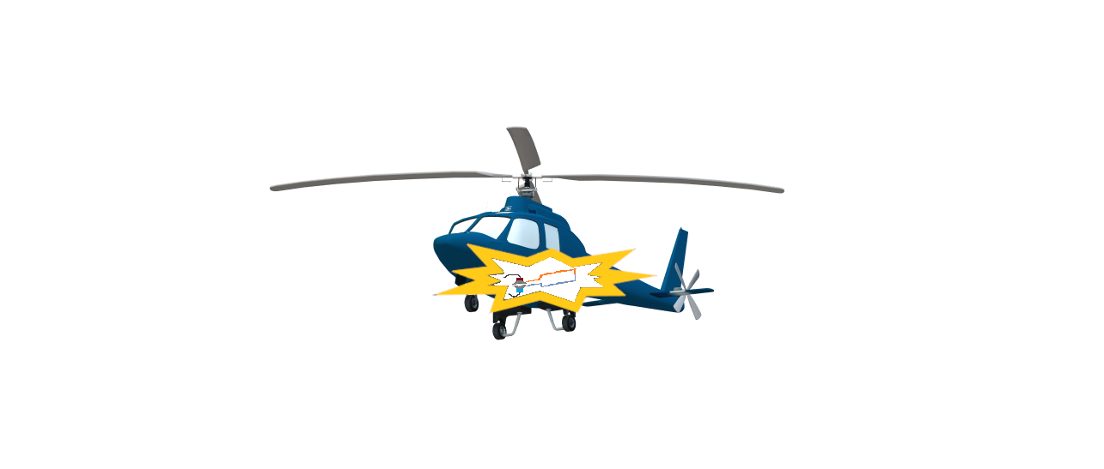

**PROJECT D:**

**DC BRUSH MOTOR**

Nathan Rosenfeld

Lauren Kocher

Table of Contents

Purpose 1

Equipment 1

Explication 2

Procedure 5

Data 7

Calculations 8

Results 11

Conclusion 11

**Purpose**

The purpose of this experiment was to build and test a functioning DC brushed motor.

**Equipment List**

DC power supply – batteries of varying voltages

Two neodymium magnets

Insulated 30-gauge copper wire

Wood-various sizes

Multimeter

Long string

Stopwatch

**Explication**

A DC motor converts the electrical potential energy of a DC circuit into mechanical energy via electromagnetic induction. Electromagnetic induction is a process wherein a voltage is induced via a changing magnetic field. When a current is supplied to a DC motor's coil through brushes and a commutator, the coil becomes an electromagnet and produces a magnetic field. This magnetic field interacts with and distorts the permanent magnetic field (the "B-field") supplied by two oppositely-charged permanent magnets (*Fig. 1*). As a result, the armature moves. This interaction is called the "motor effect".

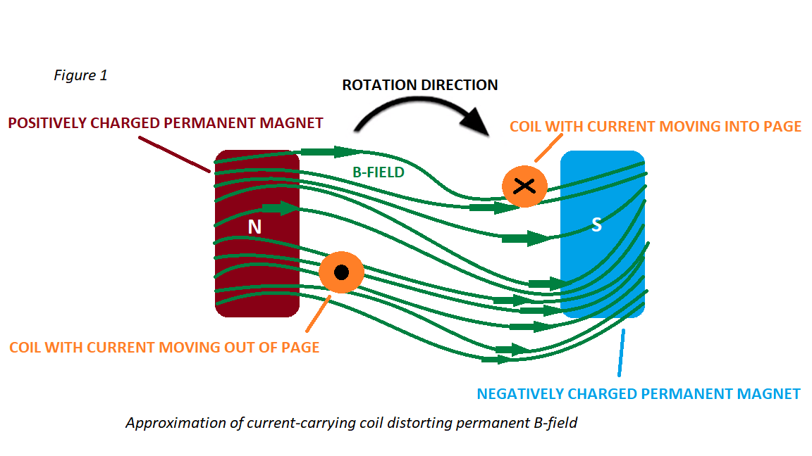

There are two types of EMF (electromotive force) associated with the operation of a motor: the applied EMF (such as the voltage provided by a power source), and induced EMF (also known as "back EMF" or "counter EMF"), which is induced by the changing magnetic flux passing through the coil as it rotates. As described by Lenz's Law, the induced EMF acts in opposition to the applied EMF, so the net EMF in the coil is *(applied EMF – induced EMF).* Furthermore, the current *(I)* in the coil is dependent on this relationship, as indicated by Ohm's Law: (*I= $\frac{(applied EMF-induced EMF)}{Resistance \left(R\right) of wire in coil})$.* Higher rotational speeds cause greater flux change through the coil, which in turn induces higher quantities of EMF. When a motor is used to power something, these values are used to determine if it can effectively overcome losses (such as from friction) and drive the load assigned to it.

Assuming a simple rectangular coil design, there are constant linear forces acting on each side of the coil while current is supplied, as a result of the interacting magnetic fields. These forces act in opposite directions to each other on either side of the coil, thereby creating a rotational force (torque) around its rotational axis. The rotational axis is perpendicular to the permanent B-field (*Fig. 2*).

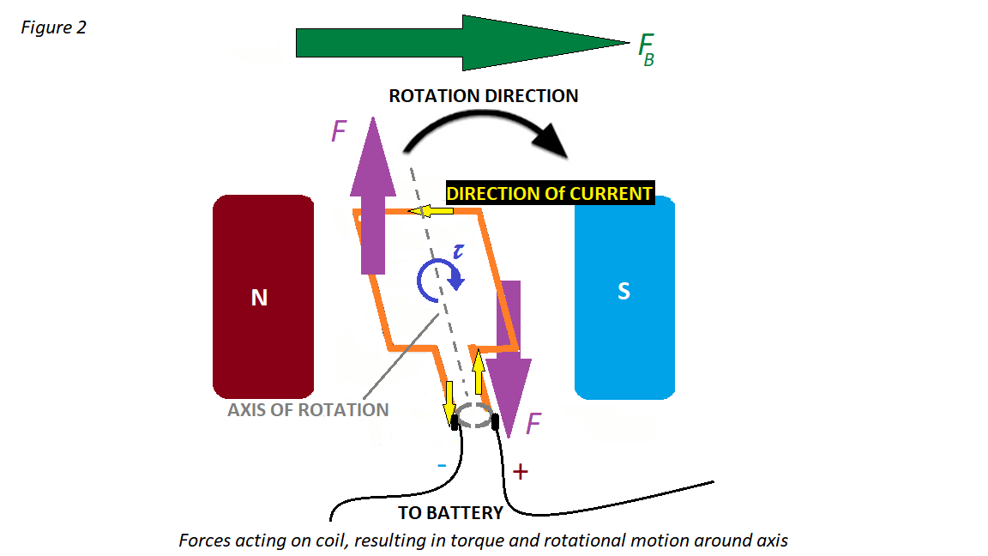

The torque varies throughout the coil's rotation, and reaches zero when the plane of the coil is perpendicular to the B-field, and a maximum when the plane of the coil is parallel with the B-field. Mathematically, this is confirmed by the torque equation, $τ=Fdsinθ$ where *d* ≡ the distance from the side of the coil to its own rotational axis, and θ ≡ the angle between *F* and *d*. When the coil's plane is parallel with the B-field, the angle between *F* and *d* is 90°, which yields a non-zero value in the torque equation, since *sin(90)=1* (*Fig. 3*). However, when the coil's plane is perpendicular to the B-field, the angle between *F* and *d* is 180°, resulting in a value of 0, because *sin(180)=0* (*Fig. 3*).

This necessitates a commutator: without a device such as a commutator to switch the direction of the current, a coil in a DC motor will only complete as much as a half-turn (180°), becoming static when it becomes perpendicular to the B-field. A commutator switches the direction of current at every half-turn, ensuring that rotational motion is sustained.

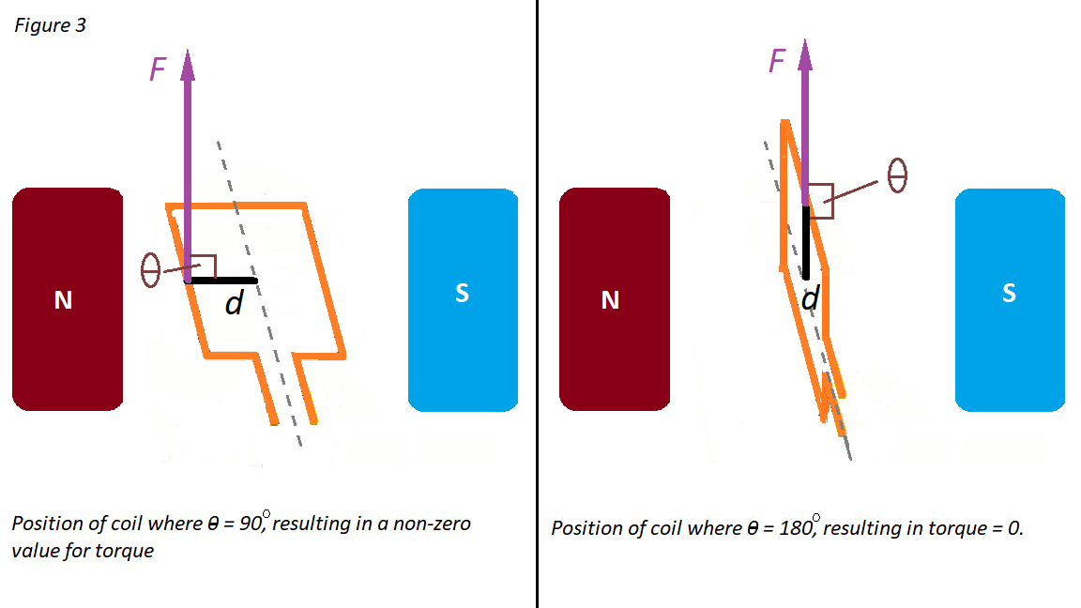

When a power source is oriented and attached to the system as shown in *Fig. 4,* the commutator ensures that the current is always traveling *towards* the observer on the left side of the coil, and always traveling *away from* the observer on the right side of the coil. These directional currents determine the polarity of the coil and interact with the permanent B-field accordingly, resulting in a clockwise rotation. If the power supply is reversed, then the coil will rotate *counter-clockwise* instead. Reversing the positions of the permanent magnets will also reverse the direction of rotation.

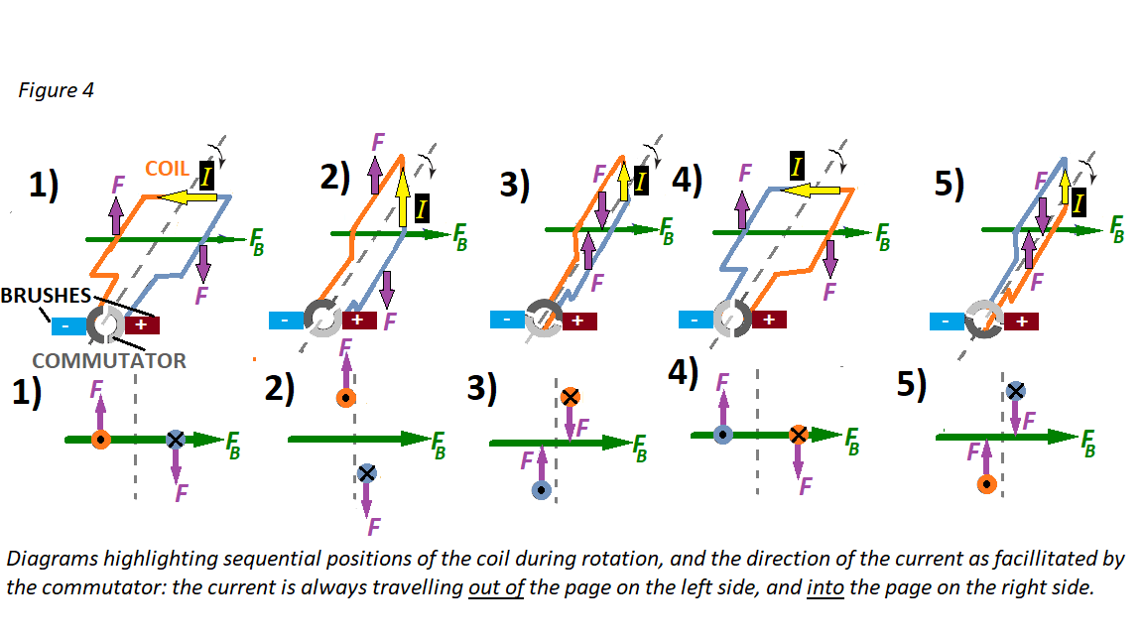

**Procedure**

A wooden dowel was used as the axle. At one end of the dowel, two rectangular pieces of wood were glued onto it to form two squares, one on each side of the dowel-each of equal size. Another two pieces were glued at each end to hold the pieces together. At this point, there was a rod with two square arms extending on each end.

The copper wire was run from the end of the dowel, wrapped around one arm many times, then around the other arm an equal number of times in the same direction, then run back to the end of the dowel.

At each end of the dowel, a commutator was formed by attaching the wire to a piece of aluminum. The aluminum was cut so that the width of each strip was approximately 1/3 of the circumference of the dowel. The aluminum strips were fastened to the dowel. See figure 5.

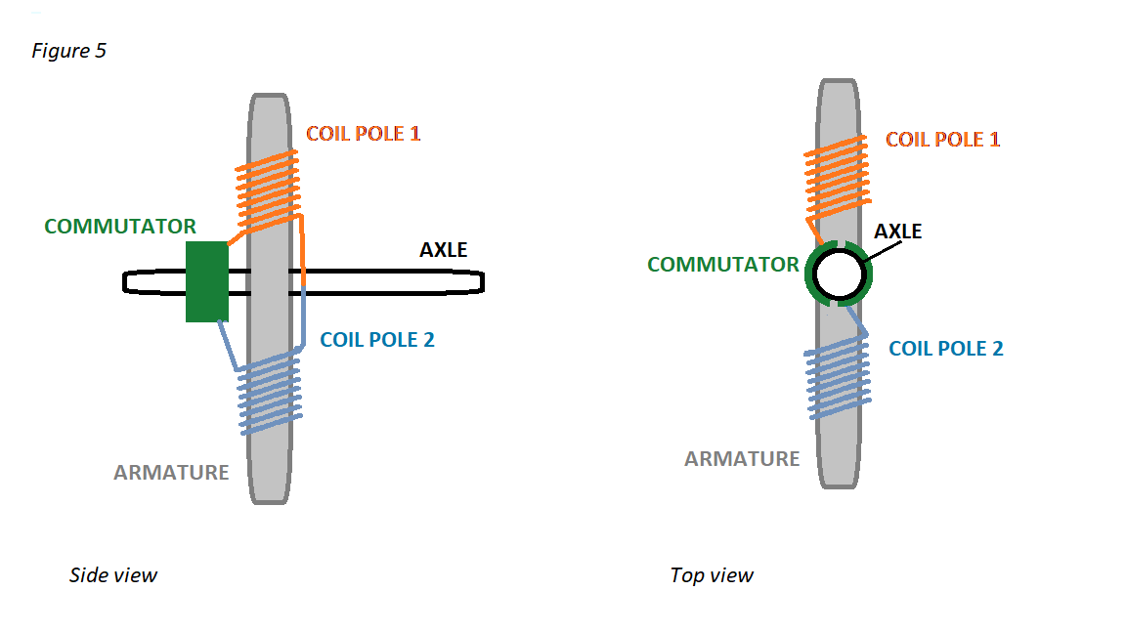

On each side of the axle in a wooden enclosure was fastened a permanent magnet. The magnets were arranged such that the north pole of the one magnet was facing the south pole of the other.

The motor brushes, two copper wires, were placed so that they could contact the commutator and remain static as the commutator rotated. The brushes were attached to a power source (*fig. 6*). The wires were situated such that, when the axle reached close to a 0 $°$ position, the wires were not touching the commutator.

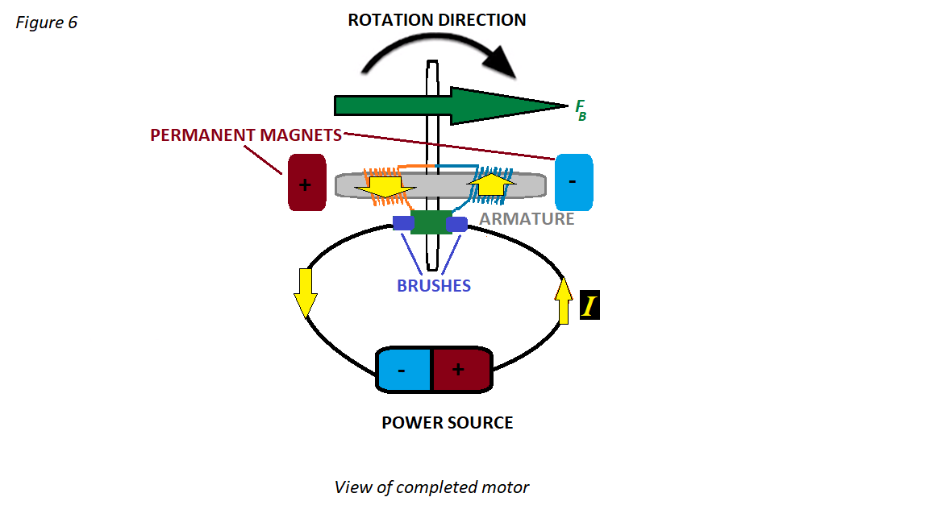

When the motor was completed, the RPM was measured by tying a piece of thin string to the motor, running the motor for a known length of time, and counting the number of loops of string that were wrapped around the axle.

Additionally, while the motor was running, the voltage and current were measured using a multimeter.

**Data**

**Number of arms –** 2

**Coils on each arm of motor-** 90

**Measured resistance of wire-** 10 Ω

**“Closed circuit phase” of circle- $\frac{π}{3}$** radians × 2

**Dimensions of each coil-** 10 mm squared

**Distance from center of rotor to center of each coil-** 10 mm

**Magnetic Field Strength –** 400 Gauss

**Calculations**

**Back EMF -Predicted**

The Voltage created by the turning of the motor is expressed by Faraday’s Law:

$ε=-N\frac{dΦ}{dt}$ where $Φ=B\int{dA}∙\sin{θ}$.

$$ε=-NBA\frac{d(\sin{θ)}}{dt}$$

$θ=\frac{t∙2π}{p}$ where p = periodicity (seconds per rotation)

$$\frac{d(\sin{θ)}}{dt}= \frac{2π}{p}\cos{θ}$$

$$ε=-NBA\frac{2π}{p}\cos{θ}$$

$$ε_{max}=-NBA\frac{2π}{p}$$

In this motor, the maximum back-emf using the 9 *V* battery is:

$ε_{max}=-\left(90\right)∙(2)(400×{10}^{-4} T)({10}^{-4} m)\frac{2π}{{98}^{-1} s}$

$$ε_{max}= -0.421 V$$

**Average Voltage – Back EMF**

The back-emf Voltage created by inductance is cyclical. The voltage is in the form of a sinusoidal wave. Because the commutator reverses the contacts of the coil every ½ cycle, the average voltage is the average through one complete “wave” ($\left[-\frac{π}{2},\frac{π}{2}\right]$).

The voltmeter measures the average (as opposed to RMS) voltage. The average voltage is:

$V_{AVG}=\frac{1}{π}\int_{-\frac{π}{2}}^{\frac{π}{2}}{V_{MAX}∙\cos\left(θ\right) dθ}$

$$V_{AVG}=\frac{2}{π}V_{MAX}$$

For the trial with the nine-volt battery:

$$V_{AVG}=\frac{2}{π}-0.421 V$$

$$V_{AVG}=-0.268 V$$

**Average Voltage - Source**

The average source voltage **VS** is the nominal voltage multiplied by the fraction of the cycle for which the circuit is closed.

**VS-avg** = **VS**  where *d* is degrees radians at which the motor powers off and on

For the nine-volt battery:

**VS-avg** = 8.28 *V $\frac{\frac{π}{3}-(-\frac{π}{3})}{π}$*

**VS-avg =** 5.53 *V*

**Voltage – Total Predicted**

The voltmeter, because it is connected parallel, reads the Voltage of the source continuously (not only when the motor is connected) less the average back-emf of the motor.

**VT = Vs + Vavg.r**  (**Vavg.r** is negative)

For the nine-volt battery:

**VT =** 8.28 *V* **+** -1.41 *V*

**Resistance**

Using Ohm’s Law:

$$V=IR$$

$$R=V/I$$

$$R=V_{avg}/I$$

The average voltage is:

**VS-avg** = **Vavg.s + Vavg.r**

So,

$$R_{Total}=(V_{avg.s} + V_{avg.r})/I$$

For the nine-volt battery:

$$R_{Total}=(5.53 V + -1.41 V)/(0.1 A)$$

$$R_{Total}=41.2 Ω$$

**Power Consumption**

The power consumed by the motor and its circuit is:

**P = I V**

**Results**

Table 1 - Results

|  |  |  |  |  |  |  |  |  |  |  |
| --- | --- | --- | --- | --- | --- | --- | --- | --- | --- | --- |
| **VS nominal (*V)*** | **VS measured (V)** | **Current (A)** | **RPM (×1000)** | **PredictedBack EMF - Max (V)** | **PredictedBack EMF AVG (*V*)** | **VTotal pred.** | **Operating Voltage- measured (V)** | **% diff. from pred.** | **Total Resistance (Ω)** | **Power Consumption (W)** |
| 3 | 3.2 | 0.05 | 2.40 | -0.181 | -0.115 | 3.08 | 3.14 | 1.79 | 62.8 | 0.157 |
| 4.5 | 4.84 | 0.06 | 3.45 | -0.260 | -0.166 | 4.67 | 4.74 | 1.40 | 79.0 | 0.284 |
| 6 | 6.32 | 0.08 | 4.05 | -0.305 | -0.194 | 6.13 | 6.17 | 0.725 | 77.1 | 0.494 |
| 7.5 | 7.95 | 0.11 | 5.58 | -0.421 | -0.268 | 7.68 | 7.62 | -0.809 | 69.3 | 0.838 |
| 9 | 8.28 | 0.1 | 5.58 | -0.421 | -0.268 | 8.01 | 7.14 | -10.9 | 71.4 | 0.714 |

Table 1 shows the results of the various trials of the motor. The trials demonstrate that the speed of the motor varies in direct proportion to the applied voltage. This can be shown clearly by plotting RPM vs. Voltage in a graph (see graph 1).

Graph 1

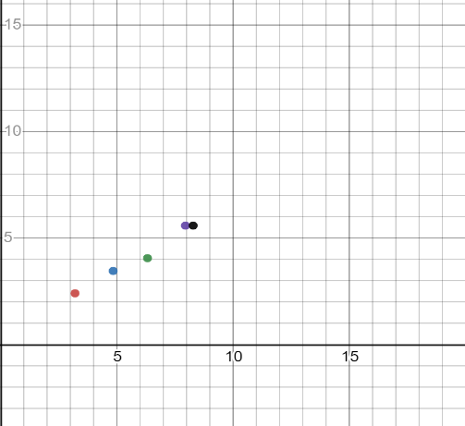

Voltage vs. RPM ×1000

The measured back-emf was also in direct proportion to the applied voltage.

**Conclusion**

The purpose of this experiment was to construct and test a functioning DC brush motor.

The motor that was built according to principles of electromagnetism and motor theory was operational: its armature rotated in the permanent B-field when a current was supplied to the coil. Whether or not this motor could successfully drive a load is unknown, but since it only had two coil, its function could have been improved significantly by adding more coils, after which it would be more likely to be able to overcome losses and support a variety of different loads, leading to different uses.

Another improvement could have been made with information regarding the neutral plane in the magnetic field. A reasonable assumption may be made regarding its position; that is, that it should be positioned orthogonally in relation to the permanent B-field (vertically, when the system is viewed from the front). However, this is not factually true: in reality, since the B-field becomes distorted, it also distorts the position of the neutral plane. In *Figure 1,* the neutral plane may be visualized as a straight line traveling through the B-field, not perfectly vertically, but instead tilted so that the top of the line leans towards the left magnet (+), and the bottom leans towards the permanent magnet on the right (-). The exact angle between the neutral plane and the B-field is unknown, but it is not 0°, nor is it 90°. Knowing this value could have aided in positioning the commutator for optimal efficiency: when the gaps in a commutator are aligned with the neutral plane, it prevents events such as sparking.

Motors such as this one (but again, usually with more coils) are used in applications such as power tools, toys (see cover page), fans, and more.

As far as the measurements and tests, the clearest conclusion is that the RPM’s vary in direct proportion to source voltage. Also, that the voltage drop likewise varies in the same proportion. Both of these follow predictions based on the laws of magnetic induction and magnetic force.

What isn’t clear is the reason for the variation in the calculated resistance. When the motor was tested for resistance with the multimeter, it had a resistance of 10 Ω. While running, the resistance varied from 62.8 – 79.0 Ω. The additional resistance represents the inductance that is produced on the circuit. By the law of conservation of energy, the power put into the circuit (see Table 1 in *Results*) equals the power which comes out in the form of heat, torque applied to the axle, noise, etc.

The primary source of error was inherent in the value for magnetic field strength: this value was estimated with the aid of educational sources. The means to verify it were not accessible to the authors.

The method used here to measure RPM was not ideal. Because the rotation was so fast, it was difficult to obtain an accurate measurement of the rotation. The faster the motor went, the harder it was to accurately count the number of loops and the amount of time elapsed. Perhaps that was why the trial with the nine-volt battery was the most divergent.

The multimeter can be divergent by ±2%.

While it is not likely that the motor built in this experiment could provide the necessary power to operate any especially useful device, it could possibly be reappropriated for something else (i.e., not useful), like entertaining a cat: a cat may get hours of enjoyment watching the armature rotate.

Generally, the relative significance of a discovery or invention is a matter of historical conjecture and pretty subjective. However, the electric motor - along with such inventions as the wheel and the turntable and the discovery of the heliocentric universe – can be objectively described as revolutionary in the most literal sense of the word.